CI/CD for Python Retail App

Course Name: DevOps
Institution Name: Medicaps University – Datagami Skill Based Course

Sr no | Student Name | Enrolment Number
01 | Mohit Meharde | EN22CS301609
02 | Nancy Agrawal | EN22CS301634
03 | Niharika Panwar | EN22CS301645
04 | Nikhil Garg | EN22CS301646
05 | Mahima Sahu | EN22CS301570
06 | Naman Mangroliya | EN22CS301628

Group Name: Group 10D6
Project Number: DO-21
Industry Mentor Name: Mr. Vaibhav
University Mentor Name: Prof. Akshay Saxena
Academic Year: 2025-2026

Table of Content

1. Problem Statement & Objective
1.1. Problem Statement
1.2. Project Objectives
1.3. Scope of the Project
2. Proposed Solution
2.1. Key Features
2.2. Overall Architecture
2.3. Tools and Technologies
3. Results and Output
3.1. Screenshots / Outputs
3.2. Reports / Dashboards / Models
3.3. Key Outcomes
4. Conclusion
5. Future Scope and Enhancement
6. References

1. Problem Statement & Objectives
1. 1. Problem Statement
In modern software development, delivering applications quickly and reliably is a major challenge. Traditional deployment processes are often manual, time-consuming, and prone to human errors. Developers frequently face issues such as inconsistent environments, delayed releases, integration conflicts, and lack of proper testing before deployment.
For Python-based applications, these challenges become more significant when multiple developers contribute to the same codebase. Without an automated system, integrating code changes, testing functionality, and deploying applications require significant effort and coordination. Additionally, manual deployment increases the risk of configuration errors and system downtime.
Therefore, there is a need for an automated, scalable, and reliable solution that can streamline the entire software development lifecycle. A CI/CD pipeline addresses these challenges by automating code integration, testing, containerization, and deployment, ensuring faster delivery and improved software quality.

1.2. Project Objectives
The primary objective of this project is to design and implement a CI/CD pipeline for a Python-based application that automates the development and deployment process.
Key Objectives:
- To automate the integration of code changes using version control systems
- To implement continuous testing for early detection of errors
- To containerize the application using Docker for consistent environments
- To deploy the application automatically on a cloud platform (AWS EC2)
- To reduce manual intervention and improve deployment efficiency
- To ensure faster release cycles and improved software reliability
- To maintain a scalable and maintainable system architecture

1.3. Scope of the Project
The scope of this project focuses on the design and implementation of a Continuous Integration and Continuous Deployment (CI/CD) pipeline for a Python-based application. The system aims to automate key stages of the software development lifecycle, including code integration, testing, containerization, and deployment, thereby improving efficiency and reducing manual intervention.

The project includes integration with a version control repository, where code changes trigger an automated pipeline. The pipeline performs tasks such as code retrieval, dependency installation, and basic testing to ensure application stability. The application is containerized using Docker, enabling consistent execution across different environments and eliminating dependency-related issues.
Deployment is carried out on a cloud-based virtual server, allowing the application to be accessed remotely. The system also incorporates basic logging to monitor pipeline activities and identify errors during execution. The overall design follows a modular approach, ensuring ease of maintenance and scalability.
However, the scope is limited to a foundational CI/CD implementation and does not include advanced features such as large-scale orchestration or enterprise-level security. The project is intended to demonstrate core DevOps concepts in a practical and efficient manner.

2. Proposed Solution
The proposed solution focuses on developing a Continuous Integration and Continuous Deployment (CI/CD) pipeline for a Python-based application to automate the software delivery process. The system integrates development, testing, containerization, and deployment into a unified workflow, ensuring faster, reliable, and consistent application releases while reducing manual effort and errors.
The pipeline is automatically triggered when code is pushed to the version control repository. It performs key stages such as code retrieval, dependency installation, testing, Docker-based containerization, and deployment. This ensures that only tested and stable code is deployed. Containerization provides a consistent runtime environment, eliminating dependency-related issues.
The system is designed to be modular and scalable, allowing easy integration of new features and tools. Deployment on a cloud platform ensures accessibility and availability. Overall, the solution enhances software quality, accelerates release cycles, and improves development efficiency.

  - . Key features
- Automated Code Integration
Continuous integration of code changes from multiple developers using a version control system.

- Automated Build Process
Automatic compilation and preparation of the application whenever changes are detected.
- Continuous Testing
Execution of automated tests to validate code functionality and detect errors early.

- Docker-based Containerization
Packaging of the application and its dependencies into containers for consistent execution.
- Cloud-based Hosting
Deployment on a virtual server environment ensuring accessibility and scalability.
- Pipeline Automation using CI/CD Tools
Use of automation tools to manage and execute the pipeline stages efficiently.
- Version Control Integration
Efficient tracking and management of code changes using a centralized repository.

  - . Overall Architecture and Workflow
2.2.1 Architectural Overview
The system architecture for the CI/CD pipeline of the Python-based retail application is designed using a distributed, modular, and layered architecture. The system is divided into two primary domains: the Infrastructure Provisioning Layer and the Application CI/CD Layer, both of which operate independently yet interact seamlessly within a cloud environment.
This separation ensures loose coupling, allowing infrastructure and application components to evolve independently. The architecture leverages Infrastructure as Code (IaC) principles for automated provisioning and continuous integration and deployment mechanisms for efficient application delivery. The final system is deployed on a cloud-based virtual machine and executed within a containerized environment.
The architecture is designed to support scalability, automation, reliability, and maintainability, which are critical for modern DevOps-driven applications.

2.2.2 Infrastructure Provisioning Layer
The infrastructure provisioning layer is implemented using Terraform, which enables declarative configuration of cloud resources. The Terraform scripts define components such as virtual private networks, security groups, and compute instances.
When executed, Terraform interacts with the cloud provider’s API to provision an EC2 instance along with the necessary networking configurations. This ensures that the deployment environment is created in a consistent and repeatable manner. The use of IaC eliminates manual configuration errors and simplifies infrastructure management.
Additionally, this layer is designed to be independent of the application lifecycle, allowing infrastructure updates without affecting application functionality. This improves system flexibility and supports scalable deployments.

2.2.3 Application CI/CD Layer
The application layer is responsible for managing the CI/CD pipeline and automating the software delivery process. It is integrated with a version control system, where developers push code changes.
Upon detecting changes, the CI/CD pipeline is triggered automatically. The pipeline performs multiple stages, including code retrieval, linting, testing, security checks, and build processes. These stages ensure that the code adheres to quality standards and is free from critical vulnerabilities.
The pipeline then proceeds to containerization, where a Docker image is built using the application code and its dependencies. This ensures that the application can run consistently across different environments. The generated image acts as a deployable artifact in the system.

2.2.4 Containerization and Deployment Layer
The containerization layer plays a crucial role in ensuring portability and consistency. The Docker image generated during the CI/CD process encapsulates the application, its dependencies, and runtime configurations.
This image is deployed onto the EC2 instance, where it is executed as a container. The container provides an isolated environment, ensuring that the application does not interfere with the host system or other applications. Deployment is performed using secure methods such as SSH or container registries.

The deployment layer also ensures that the application is accessible to users via exposed ports and network configurations.
2.2.5 Application Execution and Integration Layer
Once deployed, the application runs inside a Docker container and consists of multiple components, including a user interface, backend processing modules, and data interaction layers.
The user interacts with the system through a web interface, which communicates with backend services to process requests. The backend may include modules for data scraping, processing, and AI-based analysis. The system also integrates with external services such as databases and APIs to enhance functionality.
This layer ensures efficient data processing, response generation, and user interaction.

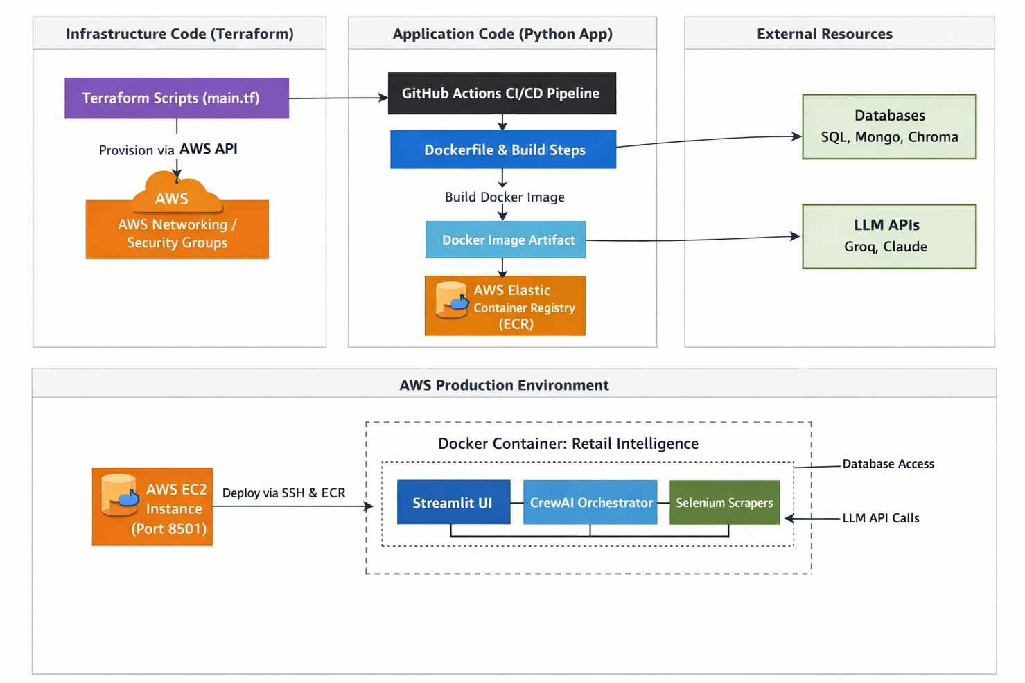

  - .Tools & Technologies Used
The system utilizes a combination of DevOps, cloud, and development tools to automate the CI/CD pipeline, ensure efficient deployment, and maintain application performance. The selected technologies support scalability, automation, and reliability.
2.3.1 Version Control System
- Git
Used to track code changes, manage versions, and enable collaboration between developers.
- GitHub
Hosts the project repository and integrates with CI/CD pipelines for automation.

2.3.2 CI/CD Automation Tool
- GitHub Actions
Automates build, test, and deployment workflows triggered by code commits.

2.3.3 Programming Language & Framework
- Python
Core language used to develop the application and backend logic.
- Streamlit
Used to create an interactive web-based UI for the retail application.

2.3.4 Containerization Technology
- Docker
Packages the application and dependencies into a container for consistent deployment.

2.3.5 Cloud Platform & Infrastructure
- Amazon Web Services
Provides cloud infrastructure for hosting and deployment.
- Amazon EC2
Used to run the Docker container and host the application.
- Terraform
Automates provisioning of cloud resources like EC2 and networking.

2.3.6 Testing & Code Quality Tools
- Pytest
Executes automated test cases to validate application functionality.
- Flake8
Checks code for syntax errors and coding standard violations.
- Black
Automatically formats code to maintain consistency.
- Bandit
Detects security vulnerabilities in Python code.
The above tools collectively enable automated CI/CD workflows, efficient deployment, and reliable system performance while minimizing manual intervention.

3. Results & Output

Fig 3.1: CI/CD Pipeline Execution using GitHub Actions
The figure shows the successful execution of the CI/CD pipeline, where all stages including build, test, and deployment are completed without errors, ensuring code quality and automation.
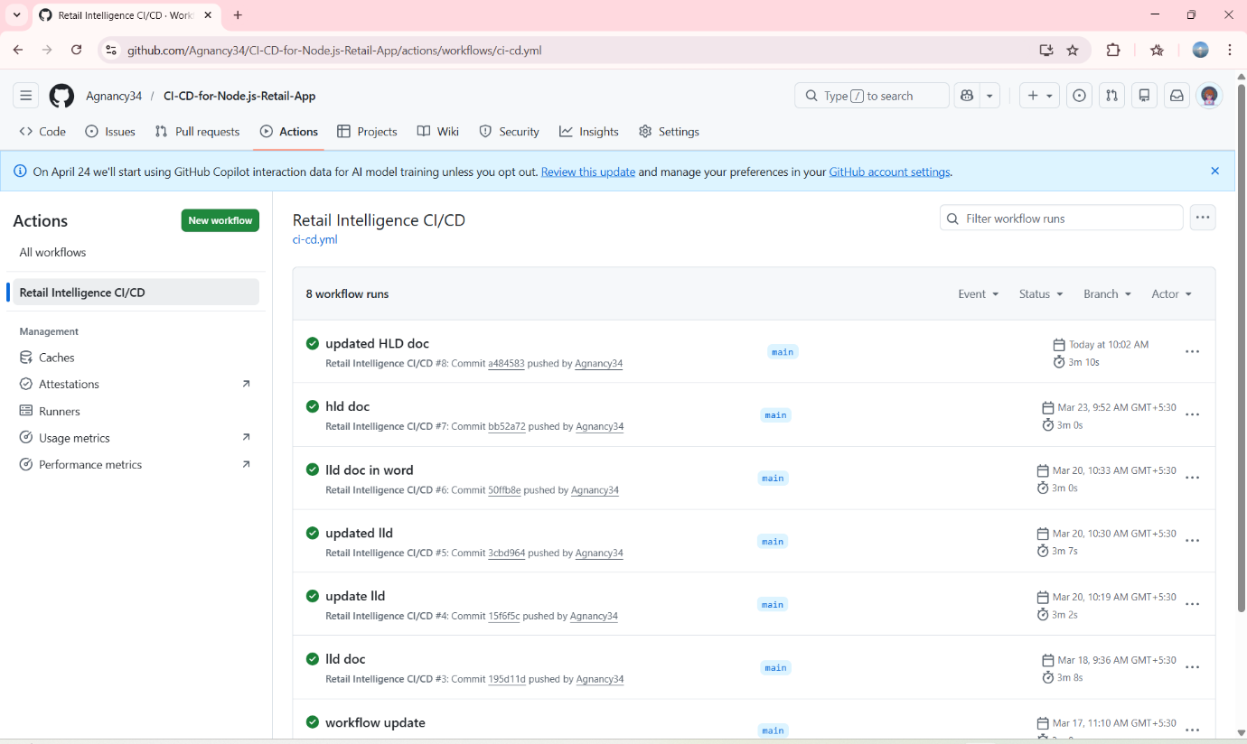

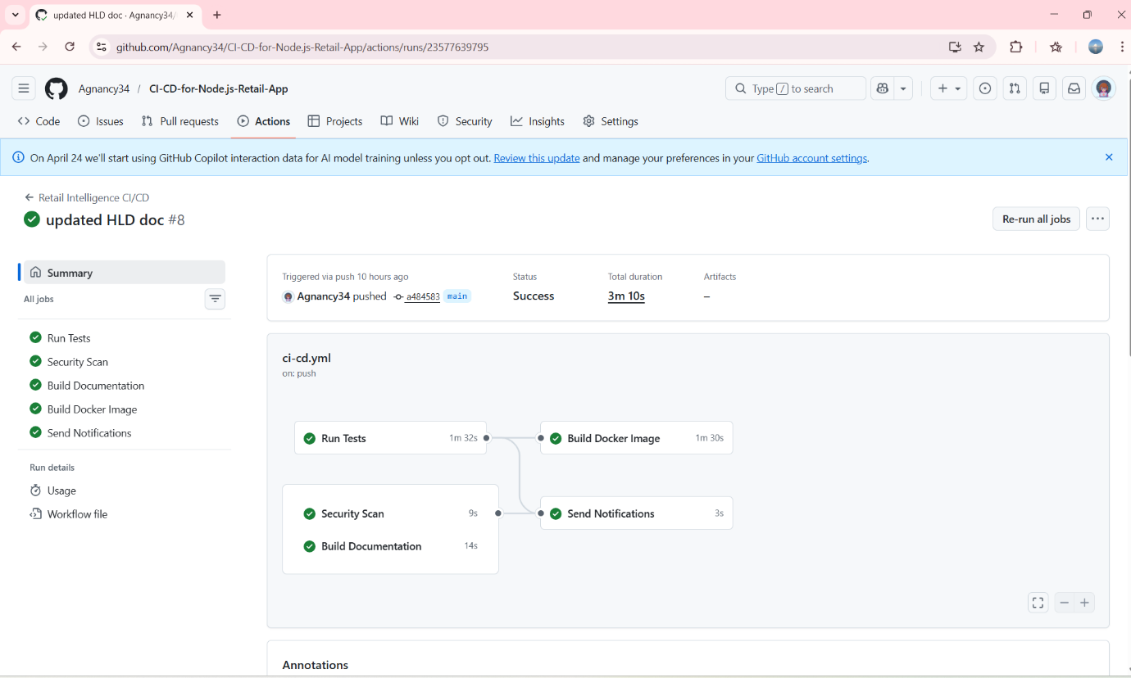

Fig 3.2: Infrastructure Provisioning using Terraform
The figure illustrates the automated provisioning of cloud resources using Terraform, where the EC2 instance and associated infrastructure are successfully created.
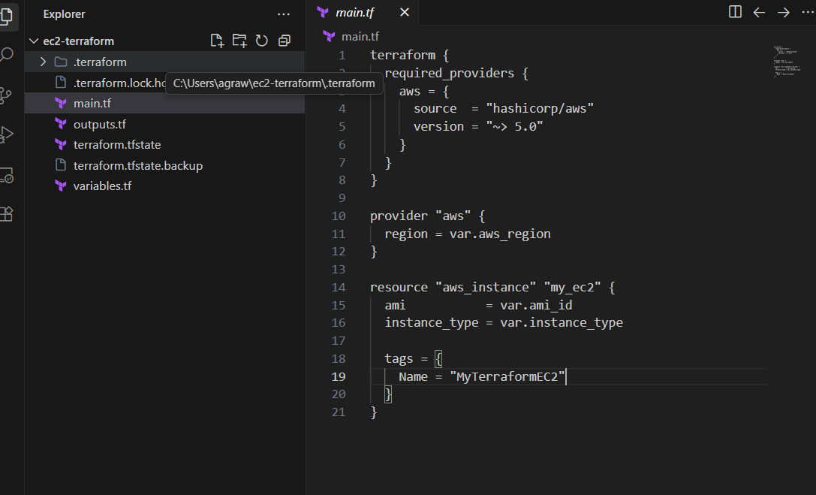

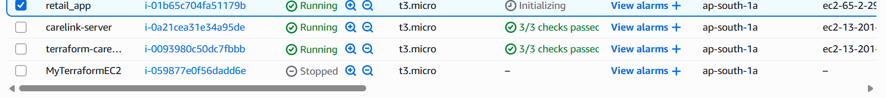

Fig 3.3: Docker Image Created on AWS EC2 Instance
The figure displays the Docker images available on the EC2 instance, confirming successful build and transfer of the application image.
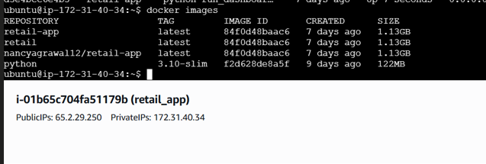

Fig 3.4: Running Docker Container on EC2
The figure shows the active Docker container running on the EC2 instance, indicating successful deployment and execution of the application.
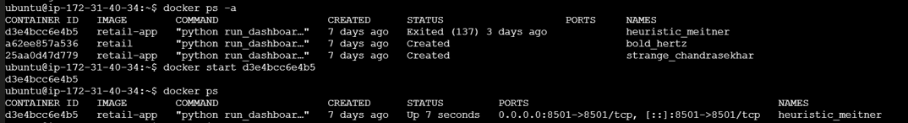

Fig 3.5: Deployed Application Accessible via Public IP Address
The figure demonstrates that the application is successfully deployed and accessible through the public IP address, confirming end-to-end pipeline execution.
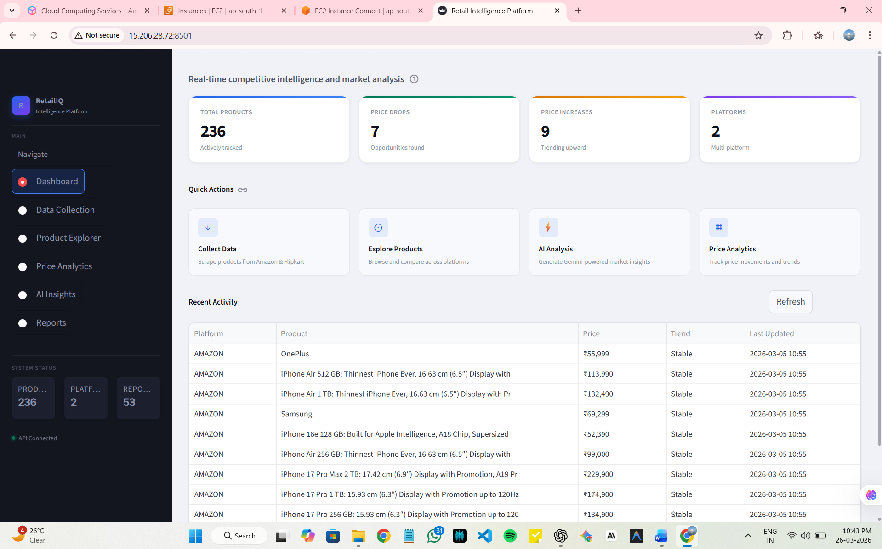

  - Key outcomes
The implementation of the CI/CD pipeline for the Python-based application resulted in several important outcomes. The system successfully automates the complete software development lifecycle, from code integration to deployment, reducing manual effort and minimizing errors.
The project demonstrates the effective use of DevOps practices, including continuous integration, automated testing, and continuous deployment. This leads to faster release cycles and improved code quality.
Another key outcome is the successful deployment of a containerized application on a cloud-based environment. The use of Docker ensures consistency across environments, while cloud infrastructure provides scalability and accessibility.
The integration of multiple tools such as version control systems, CI/CD pipelines, containerization platforms, and cloud services reflects real-world industry practices.

The project also enhances understanding of automation, infrastructure management, and deployment strategies.
Overall, the system achieves improved reliability, efficiency, and scalability, making it suitable for modern software development workflows.

4. Conclusion
The implementation of the CI/CD pipeline for a Python-based application demonstrates an effective approach to automating the software development and deployment lifecycle. The project successfully integrates key DevOps practices such as continuous integration, automated testing, containerization, and cloud-based deployment into a unified and efficient workflow.
Throughout the project, the system was designed to ensure that code changes are automatically validated, built, and deployed with minimal manual intervention. The use of containerization enables consistent application behavior across different environments, while cloud deployment ensures scalability and accessibility. The integration of tools for version control, CI/CD automation, and infrastructure provisioning reflects real-world industry practices.
The project also provided valuable hands-on experience in working with modern technologies and tools used in DevOps. It enhanced understanding of automation pipelines, cloud infrastructure management, and deployment strategies. Additionally, the importance of code quality, testing, and system reliability was emphasized through the implementation of automated checks and validations.
In conclusion, the project achieves its objective of developing a reliable and automated CI/CD pipeline, while also providing practical insights into modern software development workflows. The system demonstrates improved efficiency, reduced errors, and faster delivery cycles, making it suitable for real-world applications.

5. Future Scope & Enhancements
5.1 Advanced Deployment Strategies
The system can be enhanced by implementing advanced deployment techniques such as blue-green deployment and rolling updates. These strategies ensure zero-downtime deployment and improve the reliability of application updates by minimizing service interruptions during releases.

5.2 Container Orchestration and Scalability
Future improvements may include integration with container orchestration platforms such as Kubernetes. This would enable automated container scaling, load balancing, and efficient resource utilization, thereby improving system scalability and performance.

5.3 Container Registry Integration
The pipeline can be extended by integrating a container registry such as Amazon Elastic Container Registry. This would allow efficient storage, versioning, and management of Docker images, improving deployment consistency and traceability.

5.4 Monitoring and Logging Enhancements
The system can incorporate monitoring and logging tools such as Amazon CloudWatch to track application performance and system health in real time. This would help in early detection of failures and improve system reliability.

5.5 Security Improvements
Security can be further enhanced by integrating advanced security scanning tools and implementing role-based access control (RBAC) for cloud resources. This would ensure better protection of sensitive data and reduce the risk of unauthorized access.

5.6 Advanced Testing Integration
The CI/CD pipeline can be improved by adding advanced testing methodologies such as performance testing and automated regression testing. This ensures that new updates do not negatively impact existing functionalities and improves overall application reliability.

5.7 Functional Enhancements
From an application perspective, additional features can be integrated into the user interface to improve user experience. Enhancing data processing capabilities and integrating external APIs can provide more accurate and meaningful insights to users.

6. References
[1] GitHub, “GitHub Actions Documentation,” Available: https://docs.github.com/en/actions
[2] Docker Inc., “Docker Documentation,” Available: https://docs.docker.com
[3] Amazon Web Services, “Amazon EC2 Documentation,” Available: https://docs.aws.amazon.com/ec2
[4] HashiCorp, “Terraform Documentation,” Available: https://developer.hashicorp.com/terraform/docs
[5] Python Software Foundation, “Python Documentation,” Available: https://docs.python.org/3/
[6] Streamlit Inc., “Streamlit Documentation,” Available: https://docs.streamlit.io
[7] Pytest Documentation, “Pytest Framework,” Available: https://docs.pytest.org
[8] AWS, “Amazon Elastic Container Registry Documentation,” Available: https://docs.aws.amazon.com/ecr
[9] AWS, “Amazon CloudWatch Documentation,” Available: https://docs.aws.amazon.com/cloudwatch
[10] K. Hightower, B. Burns, and J. Beda, Kubernetes: Up and Running, O’Reilly Media, 2017.

